**DOCUMENTATION:**  
  
  
**Project Title:** *Archive Creatives* web page

**Date:** June 15, 2021

**Author:** James Carlo C. Astilla

**Phase 1: Initiation**

**Project Introduction:**

Introducing my simple but elegant web page which contains my Resume. My webpage is very minimalistic with some animation and cool bottons and very interactive and informative for every user. This is my personal final project for Mr.Tamayo.   
  
**Objective:**

- To design and make it look beautiful in the eyes of every user.  
- Creating a clean and simple web page about my resume

- To be a user friendly webpage

- Being readable

**Phase 2: My Web Page interface**

Home Page:

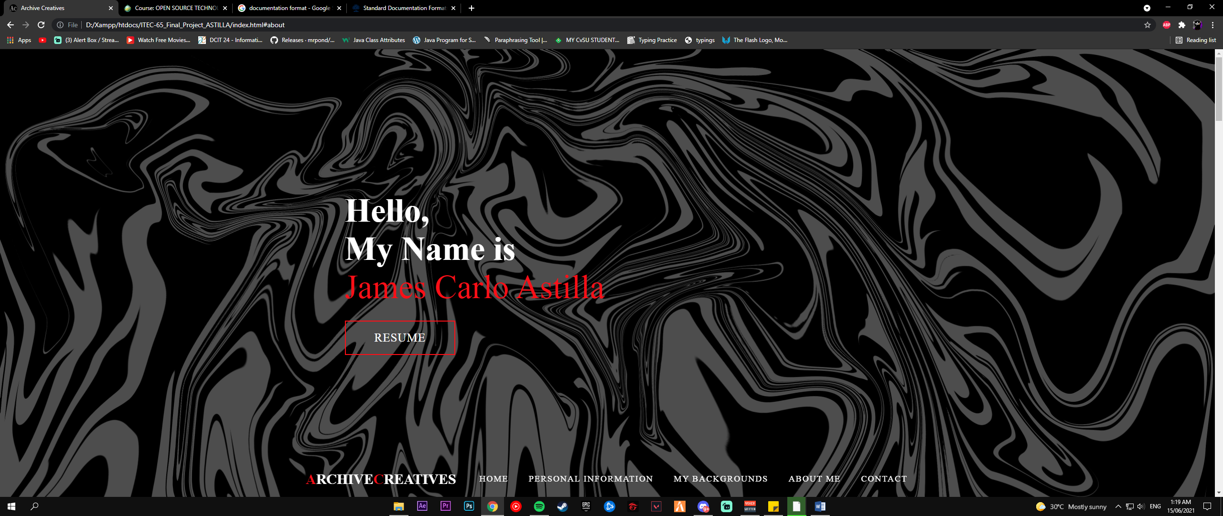

Personal Information:

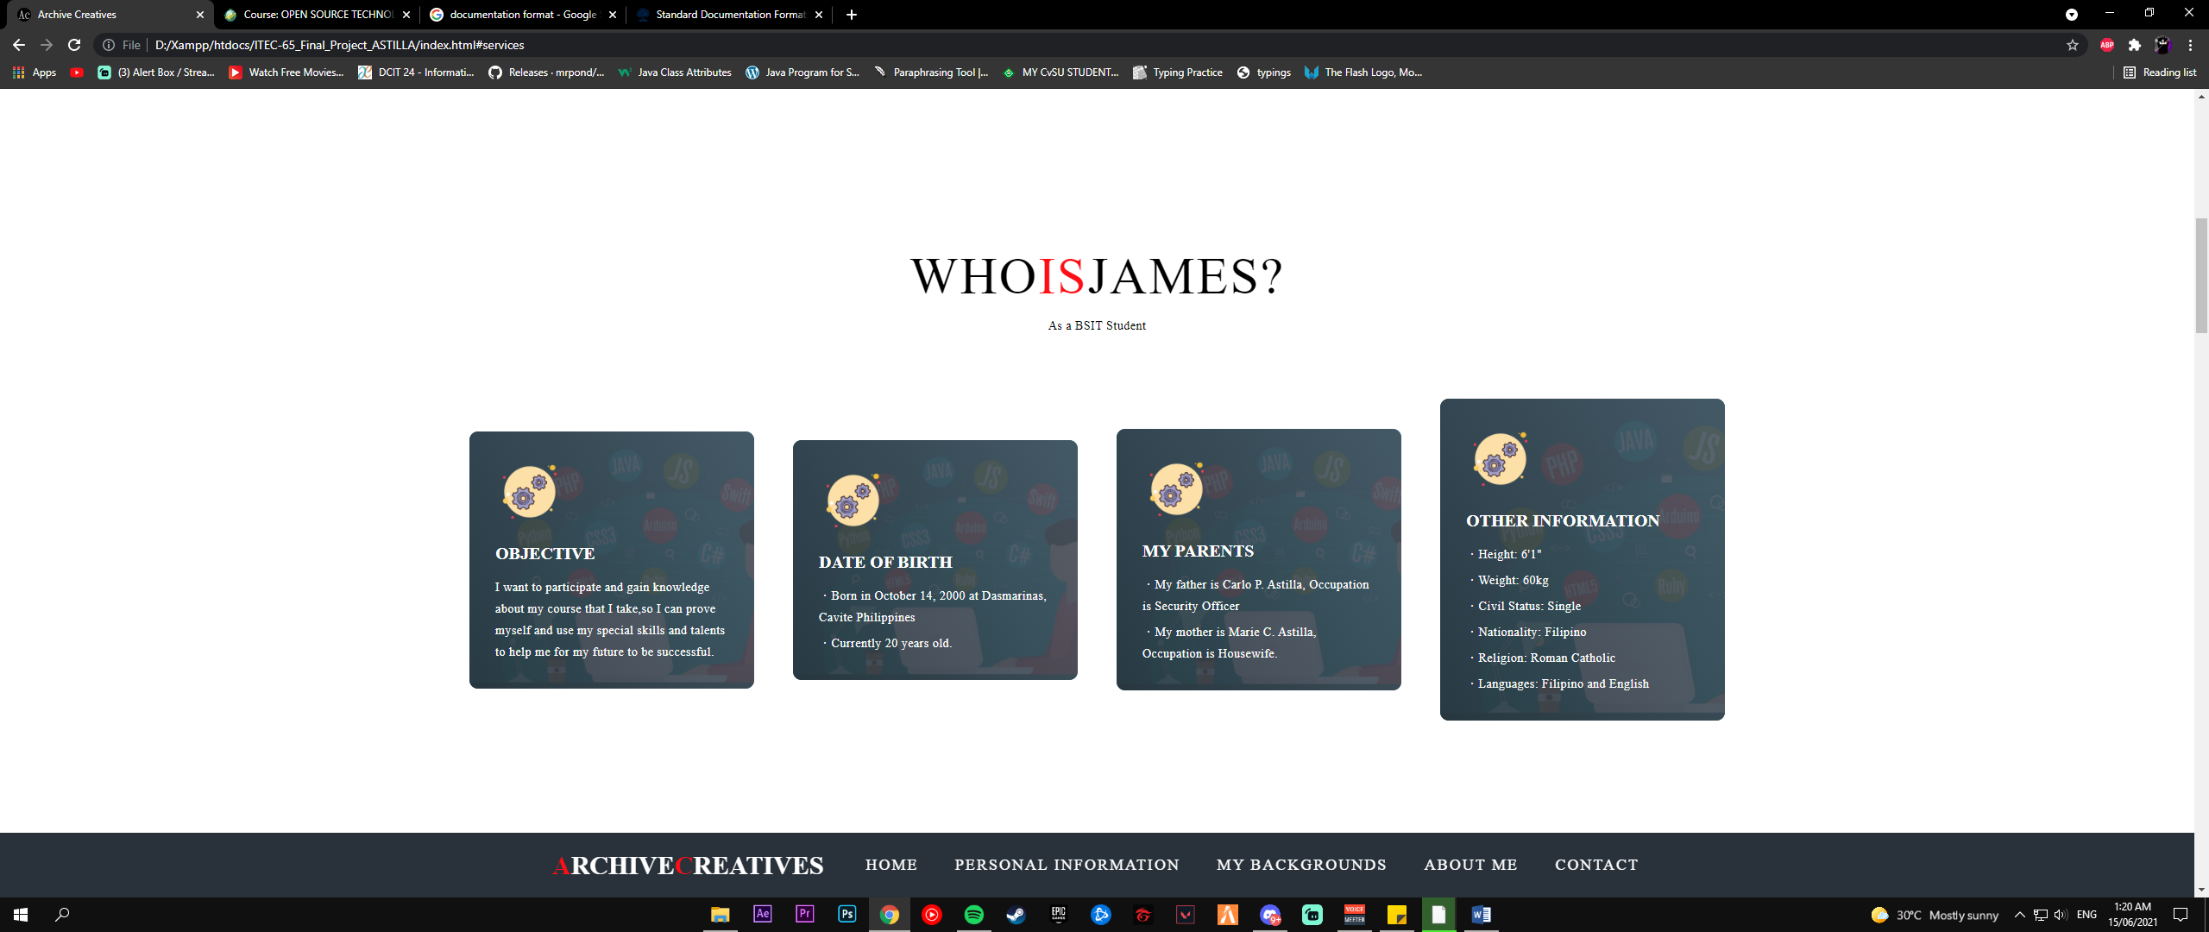

My Backgrounds:

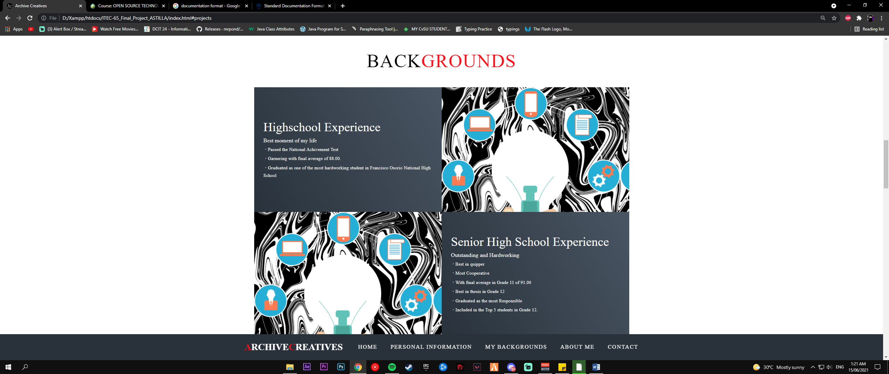

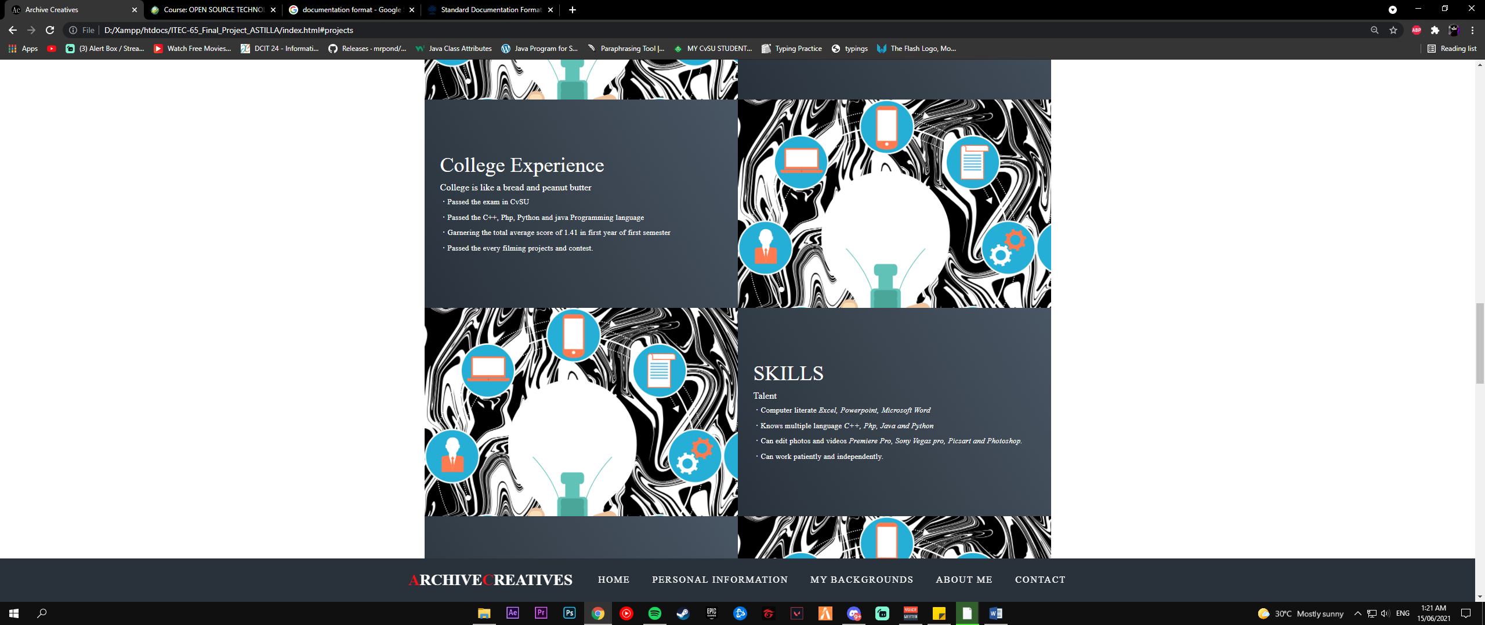

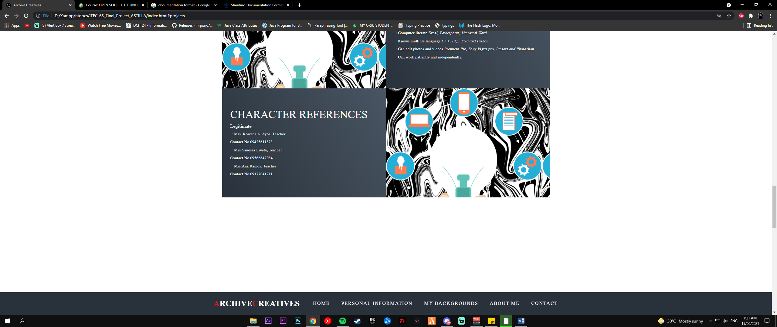

About Me:

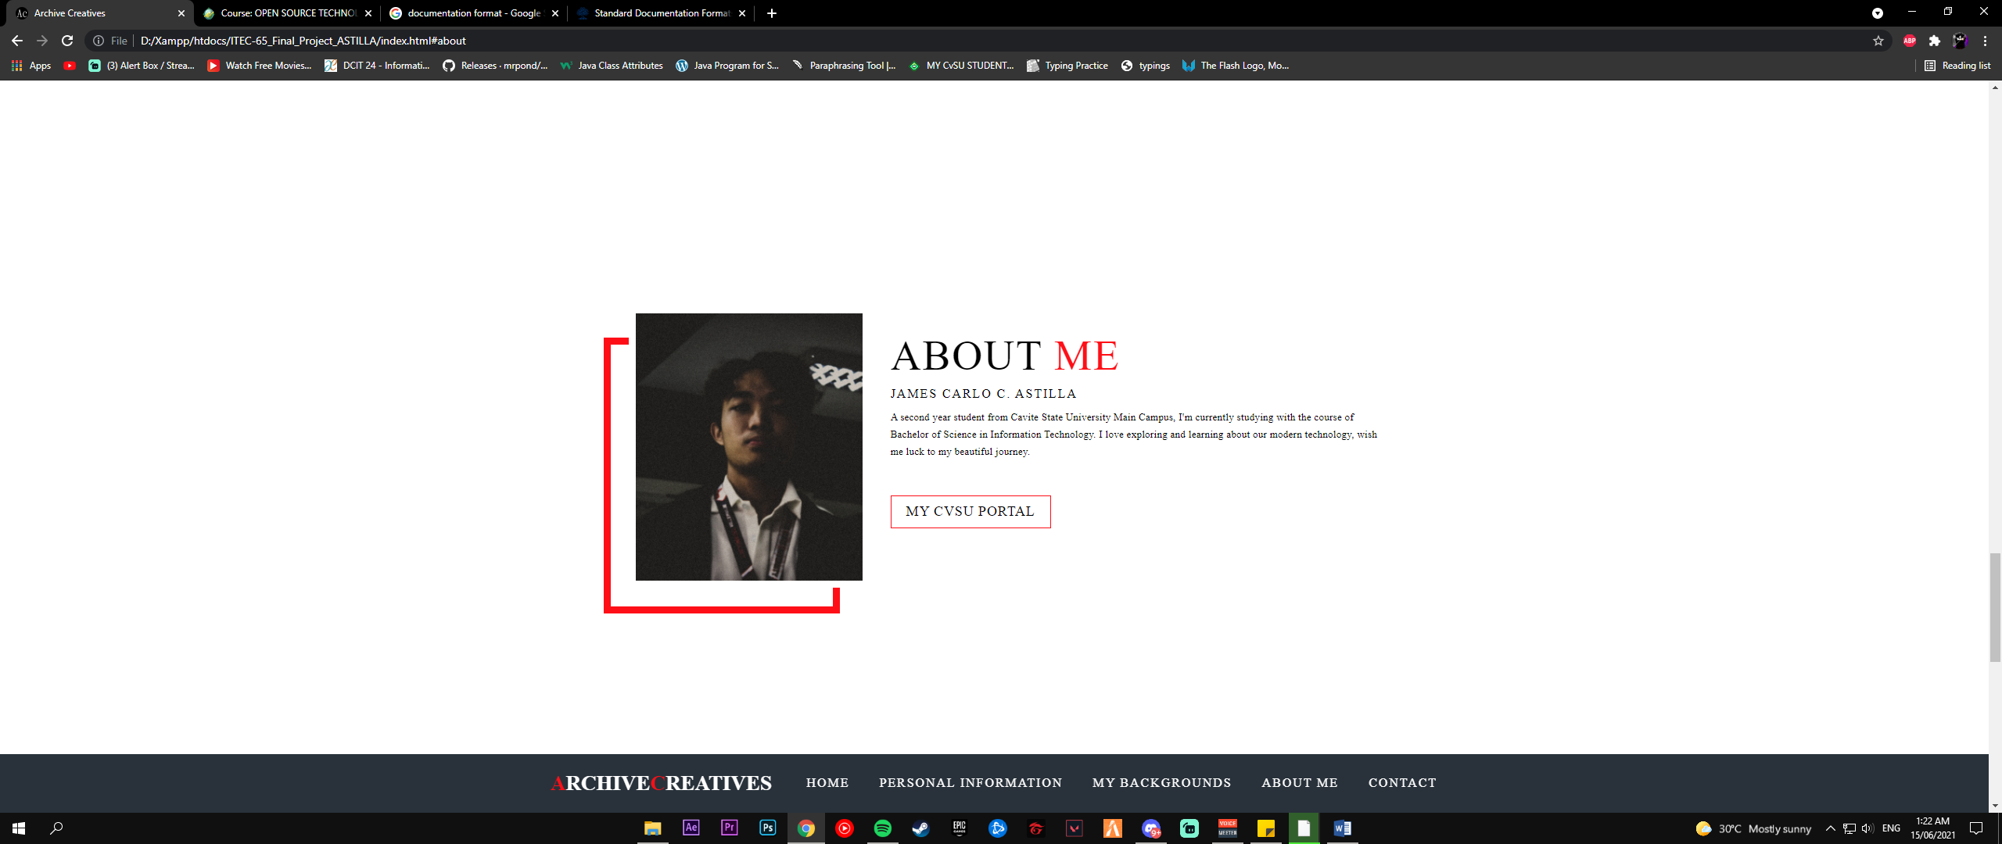

Contact:

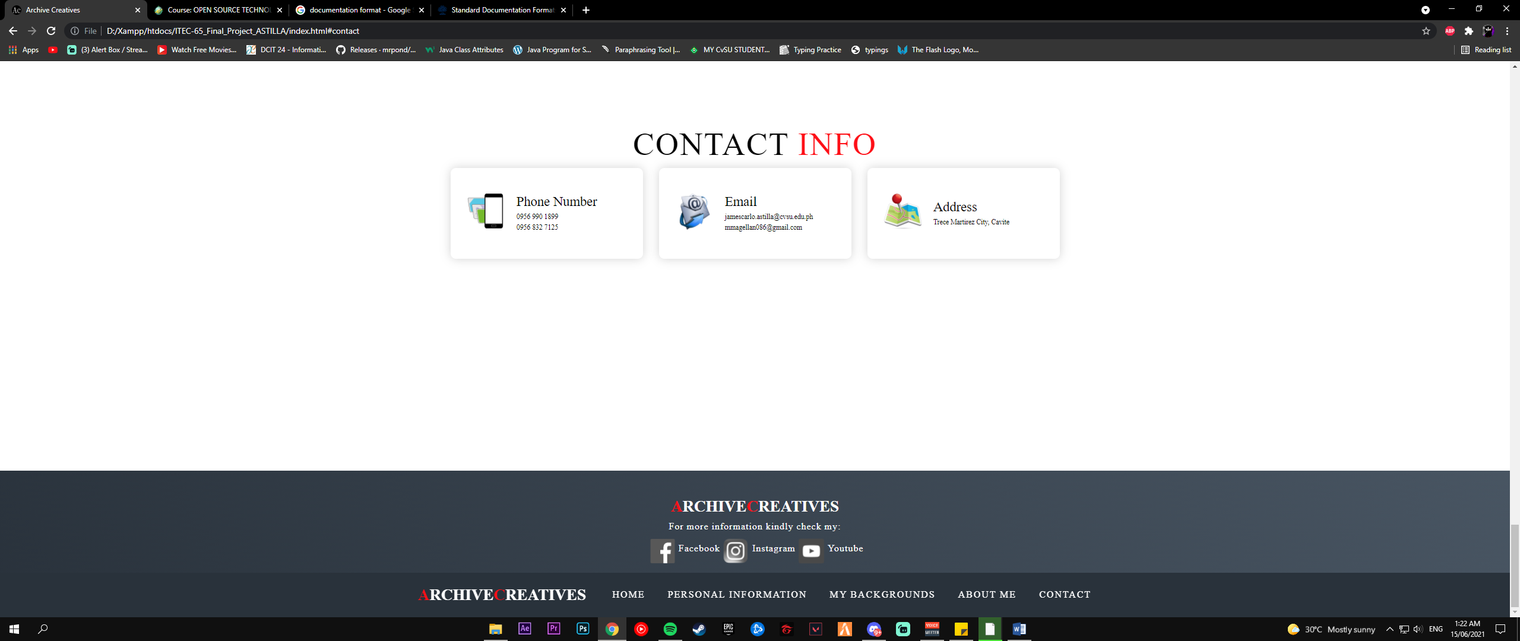

**Project Deadline:** June 16, 2021

**PHASE 3: OTHER INFORMATIONS**Directory of my Webpage:

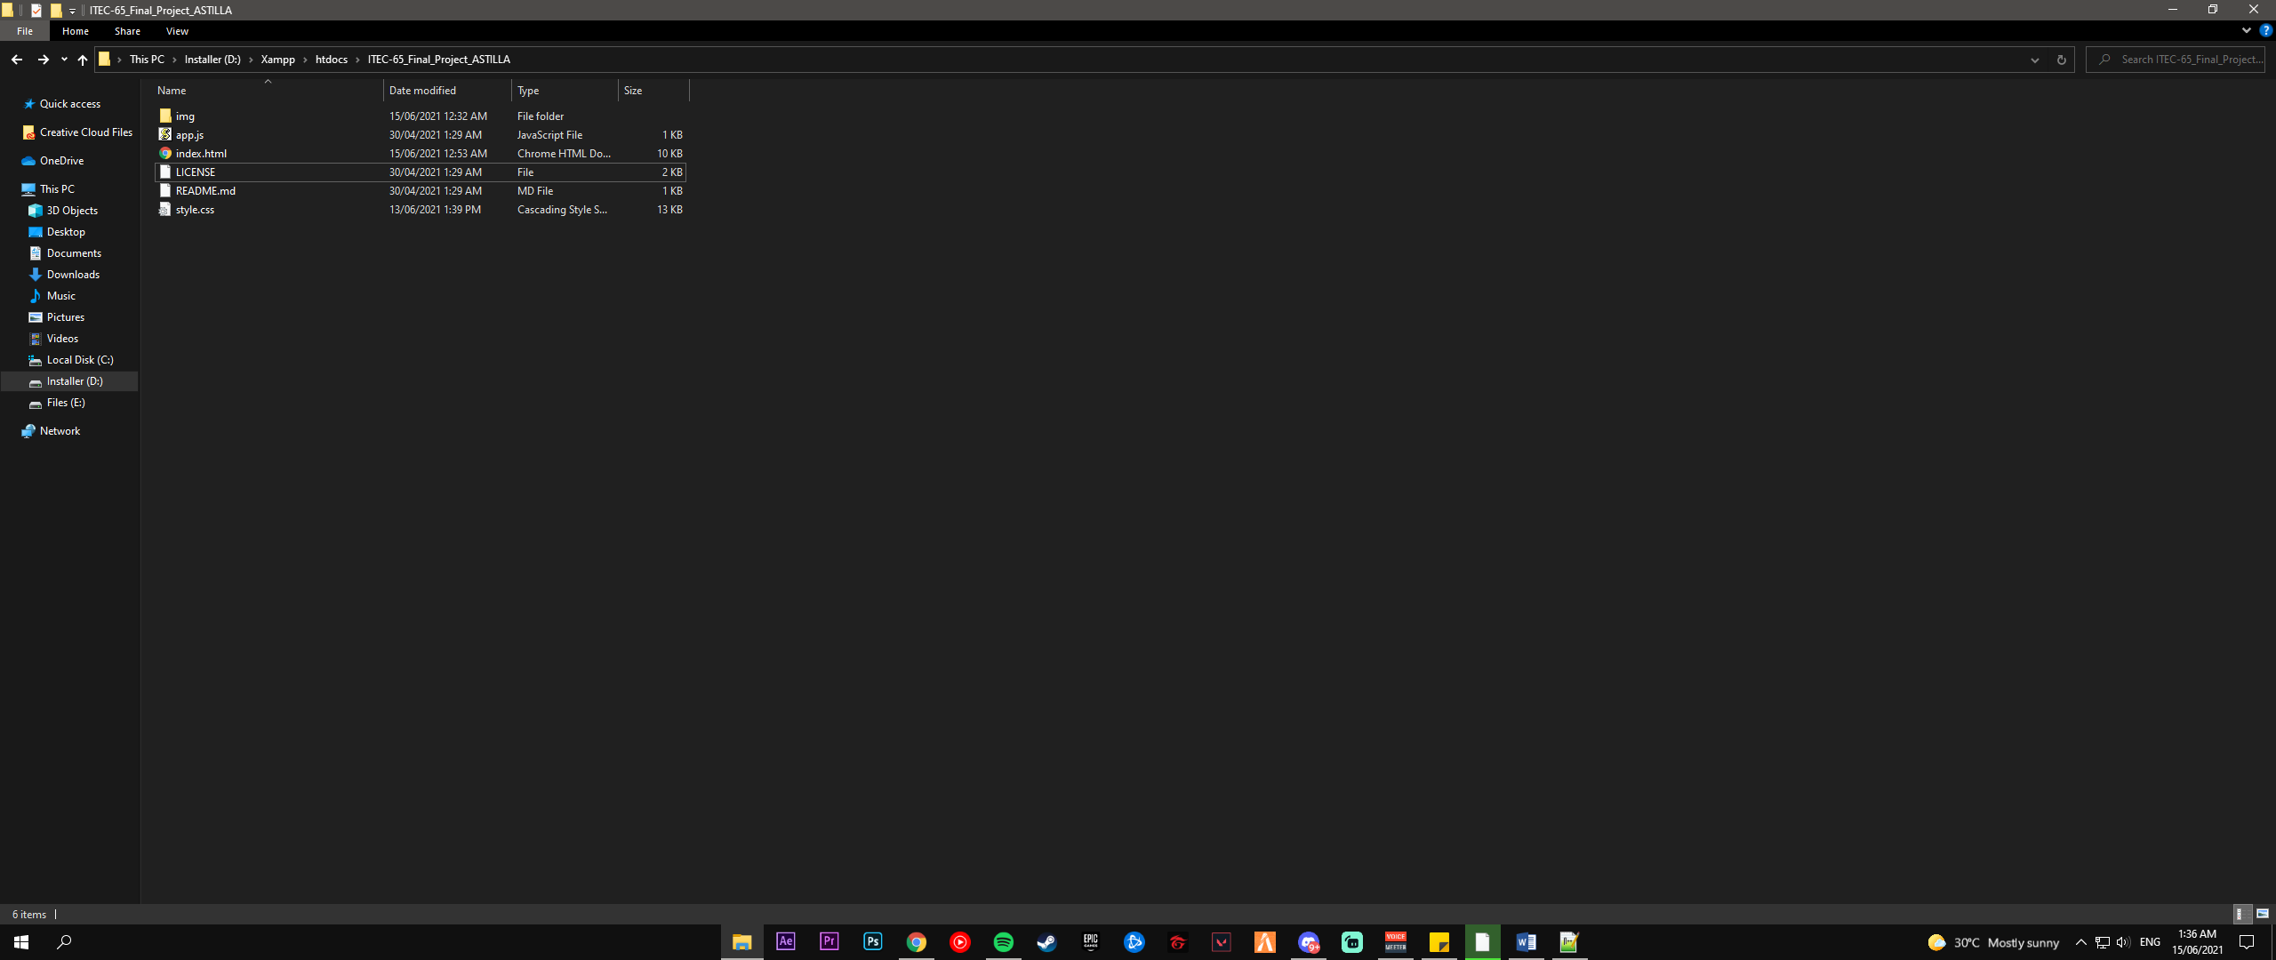

Images:

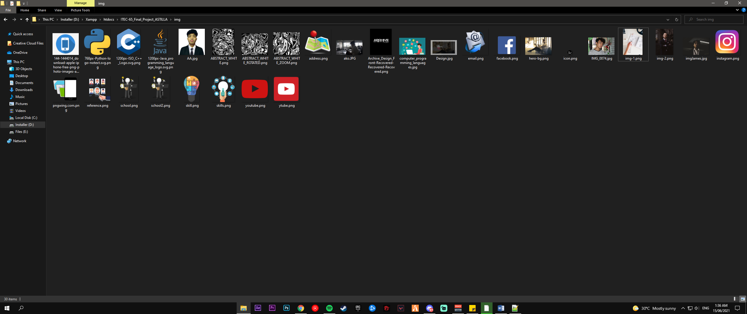

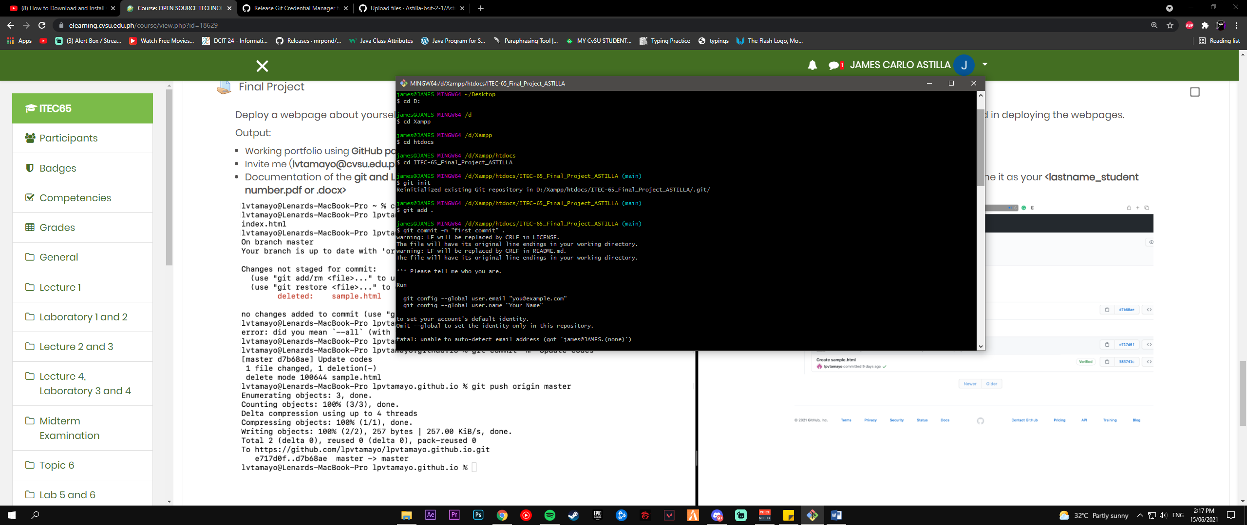**PHASE 4: Git and Linux Commands**

